800.289.3851
WILL QUESTIONNAIRE - UNITED STATES
HELPFUL INFORMATION BEFORE YOU GET STARTED!
• This Will Questionnaire is NOT your Will. It will help your Provider Law Firm prepare your Will. All questions applicable to you MUST be completed in their entirety in order to have your Will prepared.
• If you need more space to answer a question, attach a separate sheet and indicate the question number to which it pertains.
• If you have questions while filling out this form, don't hesitate to call your Provider Law Firm at the number on your membership card.
- If you need the number to your firm, call Andrea @ 800.289.3851 to purchase a plan.
Some helpful terms before you begin:
1. Estate--> Everything that you own at your passing after payment of debts and taxes. You will make decisions regarding the percentage share of your estate that you wish to give to your beneficiaries. And if you wish, you may leave specific items of property (car, investments, heirlooms, etc.) or sums
2. Will--> A document which provides who is to receive your property, who will administer your estate, who will serve as guardian of your children, if applicable, and other provisions.
1) Full name (first, middle, last) __________
All other names by which you have been known: __________
Membership Number __________
Age __________
Date of Birth (DOB) __________
Sex __________
Are you a US citizen? (Non-citizen estate taxation varies from taxation for US citizens.) __________ If no, country of citizenship __________
2) Current residence
Street address __________
City __________
County or Parish __________
ST __________
ZIP __________
Home Phone __________
Work Phone __________
3) If you are married, your spouse's full name (first, middle, last, maiden) __________
DOB __________
Date of marriage __________
Place of marriage __________
Are you currently living with your present spouse? __________
4) Do you and your spouse have a Prenuptial Agreement which identifies and disposes of separate spousal property? __________
If yes, attach copy with any filing data.
5) If either you or your spouse has been divorced, please answer the following. If not applicable, please go to question #6.
Date of marriage __________
Date of divorce judgment __________
Court rendering judgment __________
Date of spouse's death (if applicable) __________
6) Have you or your spouse created any trusts or made gifts through trusts to others? If yes, describe and include a copy. If not applicable, go to question #7.
__________
7) Do you or your spouse expect any inheritance? If yes, state from whom and how much. If not applicable, please go to question #8.
__________
8) If you have children, including adopted children, state the following for each child. If you do not have children, please go to question #15.
Full name #1 | __________
Son / Daughter | __________
Date of birth | __________
Child of Current Marriage (Y/N) | __________

Full name #2 | __________
Son / Daughter | __________
Date of birth | __________
Child of Current Marriage (Y/N) | __________

Full name #3 | __________
Son / Daughter | __________
Date of birth | __________
Child of Current Marriage (Y/N) | __________

Full name #4 | __________
Son / Daughter | __________
Date of birth | __________
Child of Current Marriage (Y/N) | __________

9) a. Deceased biological or legally adopted children if applicable.
Full name #1 | __________
Son / Daughter | __________
Date of birth | __________

Full name #2 | __________
Son / Daughter | __________
Date of birth | __________

b. Deceased child's living children if applicable:
Full name #1 | __________
Son / Daughter | __________
Date of birth | __________
Parent's Name | __________

Full name #2 | __________
Son / Daughter | __________
Date of birth | __________
Parent's Name | __________

10) If you have stepchildren, do you want them treated the same as your natural born or legally adopted children in your Will? __________
If yes, state the following for each:
Full name #1 | __________
Male/Female | __________
Date of birth | __________
Parent's Name (Y/N) | __________

Full name #2 | __________
Male/Female | __________
Date of birth | __________
Parent's Name (Y/N) | __________

11) If you have grandchildren, state the following for each. If not, go to question #12.
Full name | __________
Parent's Name | __________
Grandson/Granddaughter | __________
Date of Birth | __________
Living (Y/N) | __________

Full name | __________
Parent's Name | __________
Grandson/Granddaughter | __________
Date of Birth | __________
Living (Y/N) | __________

Full name | __________
Parent's Name | __________
Grandson/Granddaughter | __________
Date of Birth | __________
Living (Y/N) | __________

Full name | __________
Parent's Name | __________
Grandson/Granddaughter | __________
Date of Birth | __________
Living (Y/N) | __________

12) Are any of your children or other beneficiaries mentally or physically disabled or have special needs? __________ If so, note any special provisions:
__________
If so, are they presently receiving, or do you anticipate that they may apply for, SSI benefits in the future? __________ Note: If you leave a bequest, not left to a qualified trust, the recipient might be disqualified from SSI benefits.

Please read before completing question 13:
Guardian--> A person lawfully invested with the power, and charged with the duty, of taking care of the person who is incapable of doing so because of age or other incapacity. Certain states do not allow anyone other than a biological parent to be appointed as guardian of minor children in the event of one parent’s death. Please call your Provider Law Firm for instructions for your state.
13) If your children are under age eighteen (18), state the following for the person you wish to act as their guardian (custodian) in the event of your death or in case of the joint death of you and your spouse (if married). You should obtain the consent of that person(s) before executing your will.
If you do not have any minor children, please go to question #15.
Name(s) __________
Address __________
Relationship __________
If at the time of your death the person(s) named above is/are unwilling to serve as guardian (custodian), please list an alternate:
Name(s) __________
Address __________
Relationship __________

Please read before completing question 14:
Trustee--> A person appointed to manage the financial affairs of the one who is legally incapable of doing so because of age or other incapacity.

14) Do you want the appointed guardian also to be the trustee (conservator) of any assets inherited by the minor children? __________
At what age would you like your children to take control from the trustee of any inherited assets? (Must be at least 18 years old.) __________ years old
If no, please list the person or entity you wish to act as their financial custodian. You should obtain the consent of that person or entity before executing your Will.
Name(s) __________
Address __________
Relationship __________
Please list an alternate in case this person is unwilling or unable to serve:
Name(s) __________
Address __________
Relationship __________
15) Indicate how you want your assets to pass when you die.
Please check the ONE option you prefer:

Option A I want my assets to pass to my spouse and children as follows:
• To my spouse, if surviving.
• If my spouse predeceases me, my assets will be divided in equal shares to my children.
• If any of my children predecease me, that child's share shall be distributed to his or her children in equal shares.
• In the event my spouse and all of my children and descendants fail to survive me, I want my assets to be distributed as follows:
__________

Option B I am unmarried with children and want my assets to pass as follows:
• In equal shares to my children.
• If one or more of my children predeceases me, that child's share in my estate is distributed to his or her children in equal shares.
• In the event all my children and descendants fail to survive me, I want my assets to be distributed as follows:
__________

Option C None of the above. I want my assets to pass as follows:
__________
16) Do you wish to disinherit any children or grandchildren? If so list their names here. If not applicable, please go to question #17.
Note: In certain states it is not possible to completely disinherit a spouse or minor child. Please contact your Provider Law Firm for more information. __________

Please read before completing question 17:
1. Health Care Power of Attorney--> A legal document appointing a person the authority to make health care decisions on another person’s behalf. 2. Physicians Directive (also Living Will)--> A legal document containing instructions for physicians regarding your life-support preferences. 3. Executor (also Personal Representative)--> The person appointed in a Will by the testator (person making the Will) to carry out the terms of the Will.
17) Execution of a Will is the best way to determine how your property will be distributed. However, it cannot address important issues regarding health care decisions. Your Provider Law Firm will prepare a Health Care Power of Attorney and Physician's Directive* at no additional charge if prepared with your Will. * In Alabama, an Advance Directive for Health Care
Who would you like to serve as your representative responsible for making sure your health care wishes are carried out?
Full name __________
Address __________
Phone Number __________

Please list an alternate in case this person is unwilling or unable to serve:
Full name __________
Address __________
Phone Number __________
Please indicate your wishes by checking one box below:

I want this person to be able to act on my behalf immediately.

I want this person to be able to act on my behalf only upon certification by a doctor that I am no longer able to make decisions and act for myself.
18) If married and your spouse is still alive, do you want your spouse to serve as your personal representative/executor (Note: If you wish to name a no-U.S. resident, please contact your Provider Firm)? __________
* Louisiana & Missouri residents, see back cover.
Please list an alternate below. If not married or you wish to appoint someone other than your spouse, please indicate below.
Note: If you wish to name a non-U.S. resident, please contact your Provider Firm.
Full name __________
Address __________
Please list an alternate in case this person is unwilling or unable to serve:
Full name __________
Address __________
Please read before completing the following question:
Fiduciary Bond-->A type of surety bond required by the court to be filed by executors, guardians, etc., to ensure proper performance of their duties as an executor. Typically waived, especially when a spouse or family member is appointed executor.
Do you wish to waive the fiduciary bond requirement? __________
19) Many people make special provisions for family heirlooms, jewelry, or other items of special value to be distributed to friends or relatives. If you have such property and would like to leave it to a specific person, please complete the following. Note: In question #15 you indicated how you would like your assets to pass. Please fill out question #19 ONLY if you desire items with specific or sentimental value be left to a specific person. (Include a separate sheet of paper if necessary.)
Item __________
Special Identifying Features __________
Recipient __________
20) List the estimated value of your assets as of today's date. Include the dollar amount in the appropriate column(s).
 | VALUE
ASSETS | Individual Assets
a. Home | __________
b. Other real estate | __________
c. Checking, savings, or credit union accounts & certificates
1 | __________
2 | __________
d. Automobiles & Other Vehicles | __________
e. Stocks, Mutual funds & other investments | __________
f. Interest in a business | __________
g. Qualified retirement plans (e.g. 401k plan) | __________
h. Life Insurance Policies | __________
i. Miscellaneous | __________
TOTALS | __________

 | VALUE
ASSETS | Spouse's Separate Assets
a. Home | __________
b. Other real estate | __________
c. Checking, savings, or credit union accounts & certificates
1 | __________
2 | __________
d. Automobiles & Other Vehicles | __________
e. Stocks, Mutual funds & other investments | __________
f. Interest in a business | __________
g. Qualified retirement plans (e.g. 401k plan) | __________
h. Life Insurance Policies | __________
i. Miscellaneous | __________
TOTALS | __________

 | VALUE
ASSETS | Joint Community Assets
a. Home | __________
b. Other real estate | __________
c. Checking, savings, or credit union accounts & certificates
1 | __________
2 | __________
d. Automobiles & Other Vehicles | __________
e. Stocks, Mutual funds & other investments | __________
f. Interest in a business | __________
g. Qualified retirement plans (e.g. 401k plan) | __________
h. Life Insurance Policies | __________
i. Miscellaneous | __________
TOTALS | __________

 | VALUE
ASSETS | Joint Assets/Non-Spouse
a. Home | __________
b. Other real estate | __________
c. Checking, savings, or credit union accounts & certificates
1 | __________
2 | __________
d. Automobiles & Other Vehicles | __________
e. Stocks, Mutual funds & other investments | __________
f. Interest in a business | __________
g. Qualified retirement plans (e.g. 401k plan) | __________
h. Life Insurance Policies | __________
i. Miscellaneous | __________
TOTALS | __________

21) List your estimated debt in each category as applicable. Include the dollar amount in the appropriate column(s).
DEBTS | Individual Debts
a. Mortgages on home, car, etc. | __________
b. Signature Loan at Bank | __________
c. Medical or other expenses | __________
d. Other debts over $5,000 | __________
TOTALS | __________

DEBTS | Spouse's Separate Debts
a. Mortgages on home, car, etc. | __________
b. Signature Loan at Bank | __________
c. Medical or other expenses | __________
d. Other debts over $5,000 | __________
TOTALS | __________

DEBTS | Joint/Community Debts
a. Mortgages on home, car, etc. | __________
b. Signature Loan at Bank | __________
c. Medical or other expenses | __________
d. Other debts over $5,000 | __________
TOTALS | __________

DEBTS | Joint Debts/Non-Spouse
a. Mortgages on home, car, etc. | __________
b. Signature Loan at Bank | __________
c. Medical or other expenses | __________
d. Other debts over $5,000 | __________
TOTALS | __________

Confirmation of information and instructions: I confirm the information provided by me in this form is complete and accurate and that the instructions I have provided reflect my wishes.
__________ Phone number to call if questions __________
You have now completed your Will Questionnaire! Please see instructions on the next page for final steps on how to get your Will prepared.
YOUR LEGALSHIELD PLAN WILL QUESTIONNAIRE
TO HAVE YOUR WILL PREPARED:
1 After completing the Will Questionnaire, mail it to your Provider Law Firm. To get a hard copy of this, after completion go to the MANAGE tab in Shake by LegalShield and select COMPLETED. You will be able to download a PDF copy from there.

If you need to include additional information to this questionnaire, please include a separate sheet.
Registration Link:
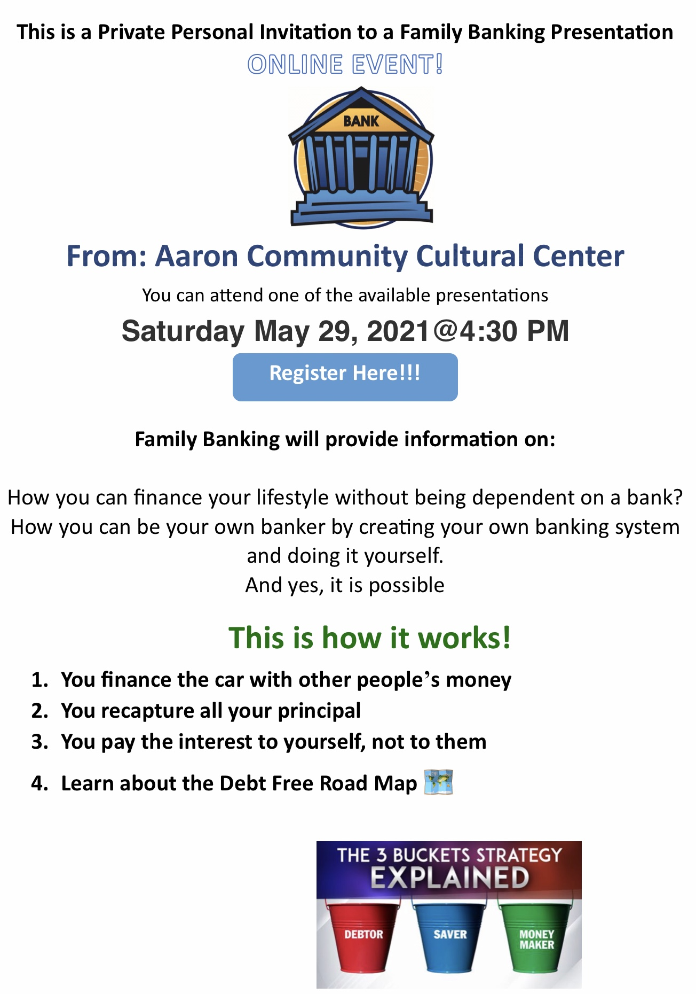
https://tinyurl.com/k2abxw6j

