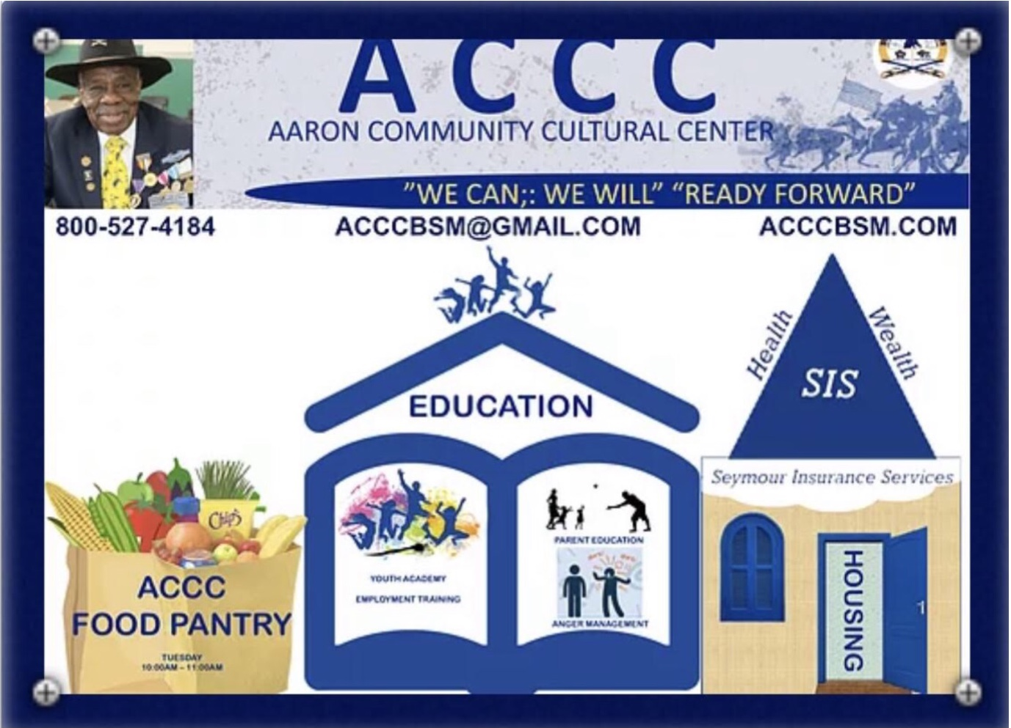
THIS IS YOUR PERSONAL INVITATION TO A LOVE YOUR LIFE & LIVE YOUR DREAM SEMINAR Sponsored ACCC
FREE!
Location: Seminars on Demand

This Seminar Will Help you IDENTIFY and DEVELOP a PLAN to ACHIVE Your DREAMS
Go To:WWW.ACCCBSM.COM

THIS IS GOING TO BE LIFE CHANGING !

Space is Limited

REGISTER TODAY!

Love Your Life Live Your Dream

Somewhere within, you’ve recognized a call to a greater life ... it beckons you into a magnificent version of who you are capable of becoming, of how you really want to live. Thousands and thousands of people step up to that greater life of their dreams ... Now it’s your turn.

Career
_____________________________________________________________________________________
_____________________________________________________________________________________
_____________________________________________________________________________________
_____________________________________________________________________________________
_____________________________________________________________________________________
_____________________________________________________________________________________

Health
_____________________________________________________________________________________
_____________________________________________________________________________________
_____________________________________________________________________________________
_____________________________________________________________________________________
_____________________________________________________________________________________
_____________________________________________________________________________________

Relationships
_____________________________________________________________________________________
_____________________________________________________________________________________
_____________________________________________________________________________________
_____________________________________________________________________________________
_____________________________________________________________________________________
_____________________________________________________________________________________
_____________________________________________________________________________________

Spirituality
_____________________________________________________________________________________
_____________________________________________________________________________________
_____________________________________________________________________________________
_____________________________________________________________________________________
_____________________________________________________________________________________

Love Your Life Live Your Dream
Somewhere within, you’ve recognized a call to a greater life ... it beckons you into a magnificent version of who you are capable of becoming, of how you really want to live. Thousands and thousands of people step up to that greater life of their dreams ... Now it’s your turn.

Career
_____________________________________________________________________________________
_____________________________________________________________________________________
_____________________________________________________________________________________
_____________________________________________________________________________________
_____________________________________________________________________________________
_____________________________________________________________________________________

Health
_____________________________________________________________________________________
_____________________________________________________________________________________
_____________________________________________________________________________________
_____________________________________________________________________________________
_____________________________________________________________________________________
_____________________________________________________________________________________

Relationships
_____________________________________________________________________________________
_____________________________________________________________________________________
_____________________________________________________________________________________
_____________________________________________________________________________________
_____________________________________________________________________________________
_____________________________________________________________________________________
_____________________________________________________________________________________

Financial
_____________________________________________________________________________________
_____________________________________________________________________________________
_____________________________________________________________________________________
_____________________________________________________________________________________
_____________________________________________________________________________________

